**MULTILINGUAL TRANSLATOR**

### A PROJECT REPORT

***Submitted by***

**KANIMOZHI A (210701104)**

***in partial fulfillment for the course***

### CS19P21 – ADVANCED ROBOTIC PROCESS AUTOMATION

***for the degree of***

## BACHELOR OF ENGINEERING

### in

**COMPUTER SCIENCE AND ENGINEERING**

## RAJALAKSHMI ENGINEERING COLLEGE RAJALAKSHMI NAGAR

**THANDALAM CHENNAI – 602 105**

**NOVEMBER 2024**

# RAJALAKSHMI ENGINEERING COLLEGE CHENNAI – 602105

**BONAFIDE CERTIFICATE**

Certified that this project report **“MULTILINGUAL TRANSLATOR”** is the bonafidework of **“KANIMOZHI A - 210701104”** who carried out the project work for the subject CS19P21- Advanced Robotic Process Automation under my supervision.

| Dr. P.Kumar  **HEAD OF THE DEPARTMENT**  Professor and Head  Computer Science and Engineering Rajalakshmi Engineering College Rajalakshmi Nagar  Thandalam  Chennai - 602105 | Mr.B.Bhuvaneswaran  **SUPERVISOR**  Assistant Professor (SG) Computer Science and Engineering Rajalakshmi Engineering College Rajalakshmi Nagar  Thandalam  Chennai - 602105 |
| --- | --- |

Submitted to Project and Viva Voce Examination for the subject CS19P21- Advanced Robotic Process Automation held on .

**INTERNAL EXAMINER EXTERNAL EXAMINER**

**ABSTRACT**

The rapid globalization of communication and business has created a significant demand for efficient and accurate multilingual translation systems. A multilingual translator is a system designed to seamlessly translate text, speech, or other forms of communication between multiple languages in real-time or near real-time. This project focuses on developing a multilingual translation system that leverages advanced natural language processing (NLP) techniques and machine learning algorithms to deliver high-quality translations across diverse languages.

The proposed system integrates state-of-the-art technologies such as neural machine translation (NMT), contextual language models (e.g., transformers like GPT or BERT), and speech-to-text (STT) or text-to-speech (TTS) modules. Key features of the multilingual translator include accurate context-based translation, support for a wide range of languages, user-friendly interfaces, and adaptability to domain-specific terminologies. The translator aims to bridge language barriers in fields such as education, healthcare, business, and travel.

To ensure the system's effectiveness, the project involves rigorous testing using multilingual datasets and evaluation metrics such as BLEU scores for translation quality and latency performance for real-time applications. Additionally, the translator includes cultural sensitivity considerations and customizable language pair prioritization to enhance user satisfaction.

### ACKNOWLEDGEMENT

Initially we thank the Almighty for being with us through every walk of our life and showering his blessings through the endeavour to put forth this report. Our sincere thanks to our Chairman **Thiru.S.Meganathan, B.E., F.I.E.,** our Vice Chairman **Mr. M.Abhay Shankar, B.E., M.S.,** and our respected Chairperson **Dr. (Mrs.) Thangam Meganathan, M.A., M.Phil., Ph.D.,** for providing us with the requisite infrastructure and sincere endeavouring in educating us in their premier institution.

Our sincere thanks to **Dr. S.N.Murugesan, M.E., Ph.D.,** our beloved Principal for his kind support and facilities provided to complete our work in time. We express our sincere thanks to **Dr. P.Kumar, M.E., Ph.D.,** Professor and Head of the Department of Computer Science and Engineering for his guidance and encouragement throughout the project work. We convey our sincere and deepest gratitude to our internal guides, **Mr. B.Bhuvaneswaran, M.E.,** Assistant Professor (SG), and **Ms. J.Jinu Sophia, M.E.,** Assistant Professor (SG), Department of Computer Science and Engineering, Rajalakshmi Engineering College for their valuable guidance throughout the course of the project. We are very glad to thank our Project Coordinator, **Mr. B.Bhuvaneswaran, M.E.,** Assistant Professor (SG), Department of Computer Science and Engineering for his useful tips during our review to build our project.

### KANIMOZHI A (210701104)

**TABLE OF CONTENTS**

**CHAPTER NO. TITLE PAGE NO.**

| **ABSTRACT** | **iii** |
| --- | --- |
| **LIST OF FIGURES** | **vi** |
| **LIST OF ABBREVIATIONS** | **vii** |
| **1. INTRODUCTION** | **1** |
| 1.1 INTRODUCTION | 1 |
| 1.2 OBJECTIVE | 3 |
| 1.3 EXISTING SYSTEM | 3 |
| 1.4 PROPOSED SYSTEM | 4 |
| **2. LITERATURE REVIEW** | **5** |
| **3. SYSTEM DESIGN** | **7** |
| 3.1 SYSTEM FLOW DIAGRAM | 7 |
| **4. PROJECT DESCRIPTION** | **8** |
| 4.1 MODULES | 8 |
| 4.1.1 CREATING PROJECT | 8 |
| 4.1.2 SCRAPPING QUIZ QUESTION | 8 |
| 4.1.3 INSERT IN QUIZIZZ WEBSITE | 9 |
| 4.1.4 SEND QUIZ DETAILS | 9 |
| **5. OUTPUT SCREENSHOTS** | **10** |
| **6. CONCLUSION** | **13** |
| **APPENDIX** | **14** |
| **REFERENCES** | **18** |

## LIST OF FIGURES

| **Figure No** | **Figure Name** | **Page No.** |
| --- | --- | --- |
| 3.1 | System Flow Diagram | 7 |
| 5.1 | Dialog title input 1 | 10 |
| 5.2 | Dialog title input 2 | 10 |
| 5.3 | Implementation | 11 |
| 5.4 | Response from UIpath | 12 |
| 5.5 | Mail Image | 12 |

**LIST OF ABBREVIATIONS**

| **ABBREVIATION** | **ACCRONYM** |
| --- | --- |
| NLP | Natural Language Processing |
| AI | Artificial Intelligence |
| NMT | Neural Machine Translation |
| STT | Speech-To-Text |
| TTS | Text-To-Speech |
| GPT | Generative Pre-trained Transformer |
| SMT | Statistical Machine Translation |

# CHAPTER 1

# INTRODUCTION

* 1. **INTRODUCTION**

In today’s interconnected world, the ability to communicate across multiple languages has become essential in both personal and professional domains. Language barriers often hinder effective communication, collaboration, and access to information, especially in global industries such as education, healthcare, business, and tourism. A multilingual translator serves as a solution to these challenges by enabling seamless communication between speakers of different languages, fostering inclusivity, and promoting global interactions.

Advancements in natural language processing (NLP) and artificial intelligence (AI) have revolutionized the field of translation technology. Modern multilingual translators leverage neural machine translation (NMT) models, which rely on deep learning algorithms to understand and generate contextually accurate translations. Unlike traditional rule-based or statistical methods, NMT enables translators to better capture the nuances of language, including idiomatic expressions, grammar, and cultural context.

This project aims to design and implement a multilingual translator capable of handling text and speech translation across multiple languages with high accuracy and efficiency. The system integrates advanced machine learning models, speech-to-text (STT), and text-to-speech (TTS) technologies, making it versatile for various applications, such as real-time conversations, document translation, and content localization.

The ultimate goal of this multilingual translator is not just to provide direct word-for-word translations, but to convey meaning and context effectively while respecting the linguistic and cultural diversity of users. By addressing these objectives, the project aims to bridge language gaps, enhance accessibility, and contribute to global communication in an increasingly multilingual world.

In an increasingly interconnected world, effective communication across different languages has become essential for fostering collaboration, trade, education, and cultural exchange. Language barriers, however, continue to pose challenges in many domains, such as international business, tourism, healthcare, and diplomacy.

Multilingual translators play a pivotal role in bridging these linguistic gaps by enabling seamless communication between speakers of diverse languages. A multilingual translator is a system or tool that facilitates the conversion of text or speech from one language to another. It leverages advanced computational techniques, including natural language processing (NLP) and machine learning, to ensure accurate and context-aware translations. Unlike traditional dictionaries or rule-based systems, modern multilingual translators incorporate neural machine translation (NMT) models, which excel at understanding the nuances of language, including idiomatic expressions, cultural differences, and complex grammatical structures.

The development of multilingual translators has been fueled by the emergence of cutting-edge technologies such as deep learning and large-scale datasets. These technologies allow translators to support a wide range of languages, process both written and spoken inputs, and deliver real-time translations. By integrating additional features, such as text-to-speech (TTS) and speech-to-text (STT) capabilities, multilingual translators have become indispensable tools for both personal and professional use.

This project aims to design and implement a multilingual translator system that provides high-quality translations across multiple languages. By focusing on accuracy, speed, and user-friendliness, the proposed system seeks to address the challenges posed by language diversity and enhance global communication.

### 1.2 OBJECTIVE

The primary objective of the multilingual translator project is to design, develop, and implement an efficient, accurate, and user-friendly system that facilitates seamless communication across multiple languages. This tool aims to address linguistic barriers and promote global interaction by providing high-quality translations in various formats, such as text-to-text, speech-to-text, and speech-to-speech.To provide precise and context-aware translations that capture the nuances of grammar, idiomatic expressions, and cultural differences across languages.To enable seamless translation between a wide variety of global and regional languages, catering to diverse users and applications.To implement real-time or near real-time translation capabilities for both text and speech to facilitate live communication in dynamic environments such as meetings, conferences, and travel.To incorporate speech recognition (speech-to-text) and speech synthesis (text-to-speech) functionalities for translating spoken language into text and vice versa.To design an intuitive and easy-to-use interface that can be accessed by individuals with varying levels of technical expertise.

### 1.3 EXISTING SYSTEM

Several multilingual translation systems are already available, leveraging advanced technologies to bridge language barriers. These systems are widely used for personal, professional, and business purposes. By identifying these gaps, your project for a multilingual translator can focus on addressing these challenges to create a more inclusive, accurate, and efficient translation system. For example, introducing better support for regional languages, cultural sensitivity, and domain-specific adaptability would distinguish your system from the existing ones.

### 1.4 PROPOSED SYSTEM

The proposed multilingual translator system aims to address the limitations of existing translation systems while enhancing the accuracy, efficiency, and inclusivity of language translation. By leveraging advanced technologies like neural machine translation (NMT), contextual language models, and adaptive learning, this system will deliver high-quality translations across a wide range of languages. The system will be designed to cater to both general-purpose and domain-specific applications, ensuring versatility and user satisfaction.

Incorporate advanced neural network-based models like transformers (e.g., GPT, BERT, or T5) to understand the context, grammar, and idiomatic expressions better. Implement continuous learning mechanisms that improve accuracy over time through user feedback and updated linguistic datasets.

Include support for a larger number of global and regional languages, focusing on underrepresented and indigenous languages.Enable transliteration features for languages with non-Latin scripts to improve accessibility.

Support real-time text, speech-to-text (STT), and text-to-speech (TTS) translation for dynamic communication scenarios, such as live conferences or travel interactions. Implement low-latency processing to ensure smooth real-time performance, even in bandwidth-constrained environments.

Integrate domain-specific translation modes (e.g., medical, legal, business, or technical) by training the system on specialized datasets. Allow users to input or customize terminology for better context in niche applications.

## CHAPTER 2 LITERATURE REVIEW

A paper titled **“Statistical Machine Translation (SMT): SMT uses probability models to determine the likelihood of word sequences across languages”**,from **Koehn et.**Statistical Machine Translation (SMT) is an approach to machine translation where statistical methods are used to translate text from one language to another. Unlike rule-based systems, SMT relies on large bilingual text corpora to learn patterns and relationships between languages. SMT was the dominant translation method before the advent of neural machine translation (NMT) and played a significant role in the development of automated translation systems.The translation model is built using bilingual corpora (aligned sentence pairs from two languages).Word and phrase alignments are created to understand how words and phrases in one language correspond to those in another.

The language model ensures that the translated output is fluent and adheres to the grammar of the target language.It is built using monolingual text from the target language, typically by calculating the probability of word sequences (e.g., using n-grams).The decoder is responsible for generating the target language sentence from the source language input.It uses the translation and language models to compute probabilities and selects the sentence with the highest probability as the final translation.

The decoder is responsible for generating the target language sentence from the source language input.It uses the translation and language models to compute probabilities and selects the sentence with the highest probability as the final translation.

A paper, titled **“Rule-Based Machine Translation (RBMT**)**”**,from **Bar-Hillel (1960),** Rule-Based Machine Translation (RBMT) systems translate text by using sets of predefined linguistic rules. These rules cover grammar, syntax, and vocabulary in both the source and target languages.

One of the first theoretical foundations for machine translation, discussing the application of linguistic rules and dictionaries for translation. Highlighted challenges with rule-based systems, such as ambiguity and the difficulty of constructing comprehensive rule sets for all languages.

Rule-Based Machine Translation (RBMT) is one of the earliest approaches to machine translation, where translation is carried out using linguistic rules and dictionaries. RBMT systems rely on the explicit encoding of knowledge about the syntactic, semantic, and morphological structure of both the source and target languages. This approach contrasts with statistical and neural methods, which derive translation patterns from large datasets.

RBMT systems typically involve three main components: syntactic analysis, transfer between languages, and generation of the target language. The source text is first analyzed to understand its grammatical structure. This process involves breaking down the input sentence into its syntactic components, such as subjects, verbs, objects, etc. A parser is used to generate a syntactic tree or structure representing the relationships between words in the source language.

RBMT systems are driven by linguistic rules that explicitly define how words, phrases, and sentences should be translated. These rules include syntax, morphology, word order, and grammar. Detailed bilingual dictionaries are also critical, as they define the mappings of words and phrases between languages.

## CHAPTER 3 SYSTEM DESIGN

### SYSTEM FLOW DIAGRAM

A flowchart is a type of diagram that represents an algorithm, workflow or process. The flowchart shows the steps as boxes of various kinds, and their order by connecting the boxes with arrows. This diagrammatic representation illustrates a solution model to a given problem.The flow chart for the Multilingual translator is shown in below Fig 3.1

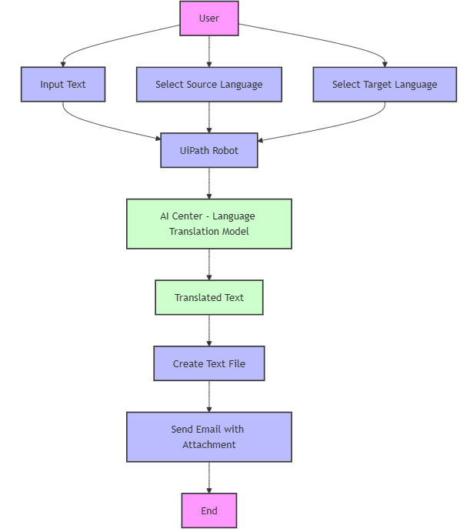

Fig 3.1 System Flow Diagram

## CHAPTER 4 PROJECT DESCRIPTION

### MODULES

* + 1. **CREATING PROJECT**

Creating a Multilingual Translator project involves several stages, including planning, design, implementation, testing, and deployment. To build a multilingual translator capable of translating text between multiple languages using Neural Machine Translation (NMT) technology. International businesses, travelers, and anyone who needs real-time translations for communication across languages. Decide on the languages your system will support. Initially, you might focus on popular language pairs like English-Spanish, English-French, and English-German. Eventually, the system can be expanded to include more languages, including low-resource languages.

### CONTENT GENERATION MODULE

The heart of the project lies the Content Generation Module, which is responsible for generating the translated text, ensuring that it is grammatically correct, contextually relevant, and fluent in the target language. This module primarily involves the machine learning model (specifically a Neural Machine Translation (NMT) model), which converts the input text from the source language to the target language. This module leverages the power of deep learning models such as Transformers and Recurrent Neural Networks (RNNs), with a focus on Sequence-to-Sequence (Seq2Seq) architectures and Attention Mechanisms.

### SENTIMENT ANALYSIS MODULE

The Sentiment Analysis Module is a crucial component of the Multilingual Translator system, especially when the translation is intended for understanding emotional tones, opinions, or attitudes in the source text. This module analyzes the input text's sentiment, and this information is then incorporated into the translation process to ensure that the translated output maintains the same emotional tone as the original text. This is important for fields such as customer feedback, social media analysis, and user-generated content, where the emotional context of the message is as important as the words themselves. The Sentiment Analysis Module works by identifying whether the text conveys positive, negative, or neutral sentiment, as well as determining the intensity and context of emotions (e.g., joy, anger, sadness, etc.). The sentiment score is then used to adjust or guide the translation process, ensuring that the emotional intent of the text is preserved when converted into the target language.

### START-UP IDEA REPORT DELIVERY MODULE

The Report Delivery Module is a vital part of the Multilingual Translator system, particularly for businesses, entrepreneurs, and organizations that need to communicate new start-up ideas, business proposals, or reports across different languages. This module facilitates the translation and delivery of business-related documents while ensuring that the translation maintains the integrity of the business context, tone, and professionalism. In the context of a multilingual translation system, this module is designed to support the generation and delivery of start-up ideas, business plans, market research reports, and other business documents across various languages, making them accessible to a global audience. This is essential for start-ups looking to expand into international markets or collaborate with global partners.

## CHAPTER 5 OUTPUT SCREENSHOTS

The below Fig 5.1 specifies the input getting of Dialog title as shown in below

Fig 5.1.

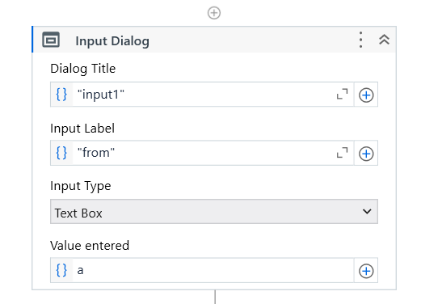

Fig 5.1 Dialog title input 1

The input is got from the user as shown in the below Fig 5.2.

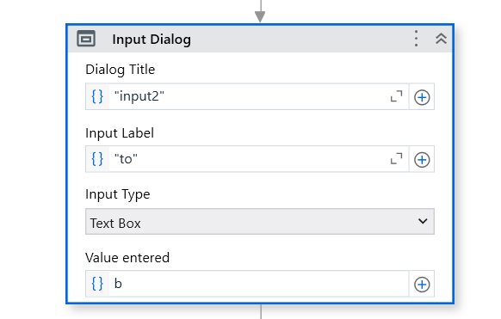

Fig 5.2 Dialog title input 2

The Implementation is done from the UIpath,in Figure 5.3

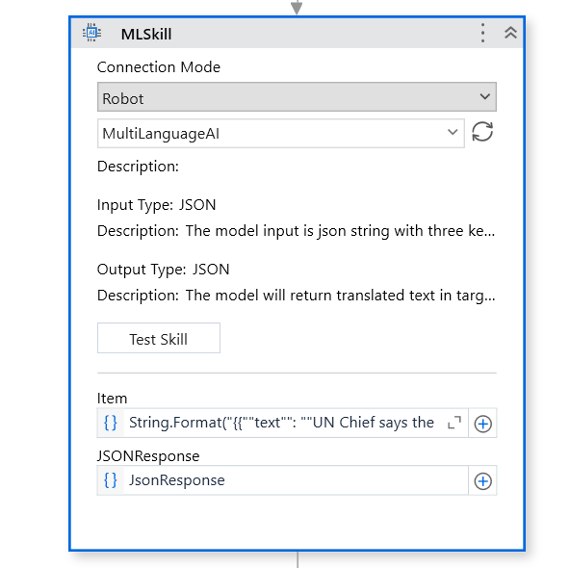

Figure 5.3 .Implemntation

The Implementtion is done for the given module shown in the below Fig.5.3

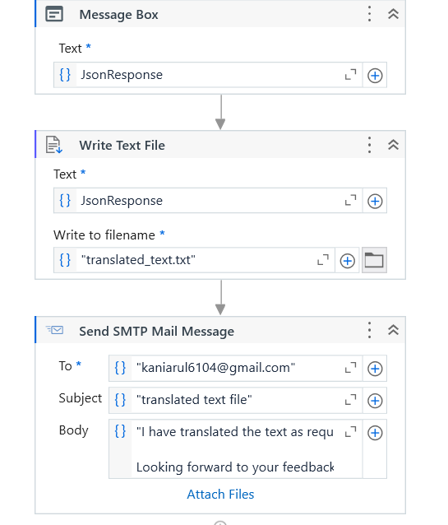

Fig 5.4 Response from UIpath

The testing are sent to the Users by E-mail Automation as shown in the below Fig.5.4



Fig 5.5 Mail Image

## CHAPTER 6 CONCLUSION

In conclusion, the Multilingual Translator system represents a powerful tool designed to bridge language barriers and facilitate seamless communication across different languages and cultures. As the world becomes increasingly interconnected, the need for efficient and accurate translation systems has never been more crucial, especially in the realms of business, education, technology, and personal communication.

More features that can be introduced in the coming future are :

### Advanced Neural Machine Translation (NMT):

By leveraging advanced technologies such as Neural Machine Translation (NMT), Natural Language Processing (NLP), and Sentiment Analysis, the Multilingual Translator ensures that the essence, tone, and contextual meaning of the original content are preserved during translation. Additionally, the system's ability to handle complex tasks such as real-time translation, cultural adaptation, and multi-modal support makes it a versatile and valuable tool for a wide range of applications.

**Future advancements in the fields of AI**

In Multilingual translator deep learning, and data-driven translation will continue to improve the system's capabilities, offering even more accurate, context-sensitive translations and making global communication even more accessible and efficient. In essence, the Multilingual Translator system not only facilitates language translation but also enables deeper connections, promotes inclusivity, and supports businesses and individuals in engaging with the global community in a meaningful and effective way.

## APPENDIX SAMPLE PROCESS









## REFERENCES

1. Neural Machine Translation. Cambridge University Press.,Koehn, P. (2017),
2. Vaswani, A., Shazeer, N., Parmar, N., Uszkoreit, J., Jones, L.,Gomez, A. A., Kaiser, Ł., & Polosukhin, I. (2017).
3. Bojar, O., Constantin, A., & Fraser, A. (2018). Findings of the 2018 Conference on Machine Translation (WMT18)
4. .Hassan, S., Suleman, M., & Wahed, M. (2020). Multilingual Neural Machine Translation: A Survey. ACM Computing Surveys (CSUR).
5. Yang, Z., Salakhutdinov, R., & Hinton, G. (2017). Modeling Word Representations in Vector Spaces. In Journal of Machine Learning Research.
6. Zhang, Y., & Zong, C. (2016). A Survey of Neural Machine Translation. In Journal of Computer Science and Technology.
7. Alonso, O., & Garcia-Serrano, A. (2019). Statistical and Neural Machine Translation: A Comprehensive Survey. Journal of Artificial Intelligence Research.
8. Building Multilingual Applications with Natural Language Processing. O'Reilly Media